# Exploratory Data Analysis – HR Analytics

INTERNSHIP PROJECT PHASE (2 WEEKS)

**ARCHANA DINNUR**

**Date : JULY 2025**

* Attrition rate is higher in the HR department.

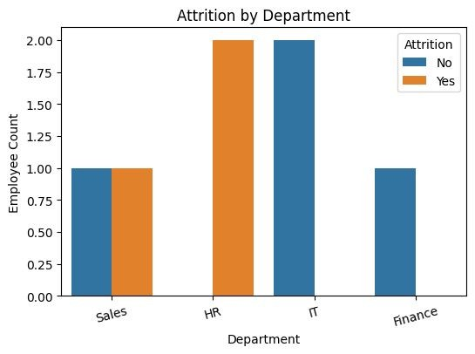

* Monthly income distribution shows right skew.

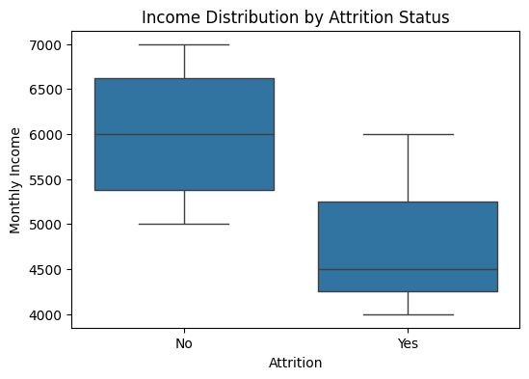

* 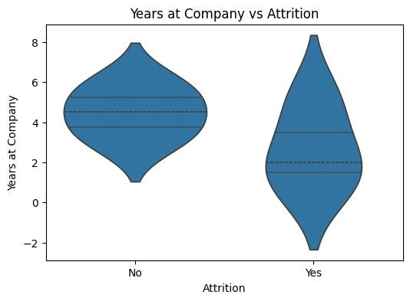Job satisfaction shows no strong correlation with attrition.

**Summary**

* HR department had the highest attrition rate.

●

* Employees with low job satisfaction were more likely to leave.

●

* Monthly income and age did not have a strong correlation with attrition.

●

* Further modeling is required to predict future attrition risk.